Fair Isle Energy Project 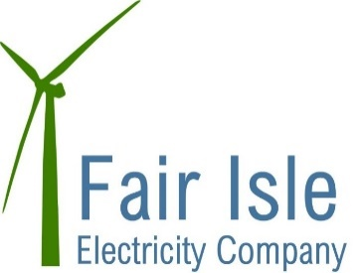

Newsletter

August 2017

Welcome to the 1st Fair Isle Energy Project newsletter! This will keep you updated with progress on the project over the next few months as we head towards the construction phase of the project and into operations.

What has happened so far.....

Project team

Over the past 15 months a project team has been put together consisting of:

Great Glen Consulting - Project Management. some of you will have met Susan Clark who is the overall project manager for us.

Arcus Consulting - designer and technical advisors - Arcus have done the main design for the project and are now leading the tender process

Harper McLeod - Legal Advisors

Scott Moncreiff - Financial Advisors

Funding

The project has been successful in attracting the full implementation phase funding it needs from the following list of organisations:

- Low Carbon Infrastructure Transition Programme (LCITP) - this is European Funding which is administered by the Scottish Government.
- Lottery
- National Trust for Scotland
- Scottish Water
- Shetland Island Council
- Highland & Islands Enterprise
- Fair Isle Bird Observatory
- Fair Isle Electricity Company

Design Development

Arcus were responsible for the overall design of the project which consists of 3 wind turbines (60kW each), a solar panel array, battery storage system and new HV distribution network.

The planning application for the cables routes, buildings and solar arrays was submitted in April and consent was granted on 2nd August. Planning for the turbines will be submitted in August/September after the bird surveys are complete.

Construction Phase

The project has been split into 3 main tenders for the purposes of getting competitive quotes for the job. These packages are:

- Turbines
- Civils - buildings, trenches etc.
- Balance of plant - HV network, cabling etc.

Packages 2&3 are out to tender just now and we expect the award of a tender in late August/early September to allow some work to start before the winter.

The turbine supply contract is being negotiated separately with this also expected to be awarded in September.

Next Steps

The LCITP funding has a stipulation that the funds must be spent and the scheme commissioned by end September 2018. This is driving the programme for the project.

We aim to start some of the civil engineering works in September so that this can get underway before the winter sets in. We hope to have a meeting before this starts with the main contractor on the island so that you can come and ask questions about what will be happening. Dates for this will be communicated via Robert and the shop.

The turbine installation will happen in the spring of 2018.

How we will keep you updated

A newsletter will be produced every month from now and circulated by FIEC. Copies will also be available in the shop. Copies will also be posted on the Fair Isle Website.

How you can help...........

If you have any questions please in the first instance send them to Robert or any of the Electricity Company Directors who will try and get a response for you.

We want to name each of the turbines and so the school will be running a wee competition to name each turbine!

