Fair Isle Energy Project 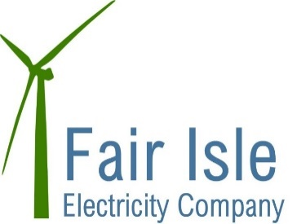
Newsletter - November 2017

Funding

Both the Big Lottery and LCITP have confirmed extra funding for the project which means we can now award the contracts for construction!!

Design Development

The planning consent for the cable route and buildings stipulated a number of planning conditions. This month we have been working on closing some of these conditions out by submitting scopes to SIC for the Ecological and Archaeological Clerk of Works who are required to monitor the project. We have also submitted a Construction Environmental Management Plan to SIC for approval. We have started to receive some feedback on the planning application for the turbines and as of yet there are no significant concerns being raised and certainly no restriction on when the turbine can be operational (like Foula) is being suggested.

Construction Phase

A pre-start meeting is being held with the Contractors on 28th November. Following this we will outline the construction timescales to you and describe what will be happening and when.

There are 2 main contracts – 1) the civils engineering & balance of plant, and 2) turbines. Following the contract award we will let you know who they are and will advise you the communication channels to be used during the construction phase.

In the first instance the contractors will all be finalising their plans, ordering materials and firming up on logistics so that we get a flying start as soon as we can.

Other things

We are pleased to say that the new lease has been agreed with NTS. Discussions have also been held with NTS about what to do with the old turbines. There is some interest in being able to retain some parts of the oldest as a heritage feature somewhere but the merits of this have still to be fully explored.

How you can help...........

If you have any questions please in the first instance send them to Robert or any of the Electricity Company Directors who will try and get a response for you.

