Fair Isle Energy Project 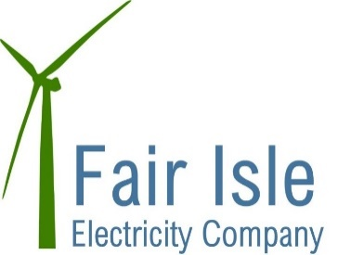
Newsletter - February 2018

Design Development
The Turbine planning consent has been granted! It is not without conditions which we are working through but we now have all the consents in place to proceed.

Construction Phase
CHAP – have been on site since 5th February and are settled into their accommodation – they have nothing but compliments for their cooks! You will have noticed them working on the cable trenches and seen deliveries of plant and materials. Nick Riddiford is working with them as the Ecological Clerk of Works to ensure we are protecting the ecological features we pass by.

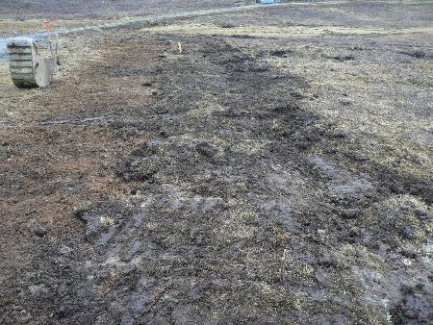

Photo 1: restored line, Vatstrass, 19th February 2018

SSE have also been on site doing some of the surveys required to inform their design. We aim to get information to you soon about power out-tages they will need to take as part of their installation, testing & commissioning. It is anticipated that they will be on site in early April to start the installation of kit required in the houses. We will update you further on this when we have a firm programme. We will also need to shut down the existing turbine at some point and then complete the new installations. This will mean that power will be diesel only for a while. SSE are working through the programme for this and we will advise you of this as soon as we can.

Harbon – whilst there is no visible sign of the turbine works on Fair Isle yet, Harbon are busy working on the turbines and indeed have already undertaken some factory testing. The photos below show progress of the turbine chassis fabrication. The pupils at the school are going to be naming the turbines and we hope to be able to tell you their names soon!

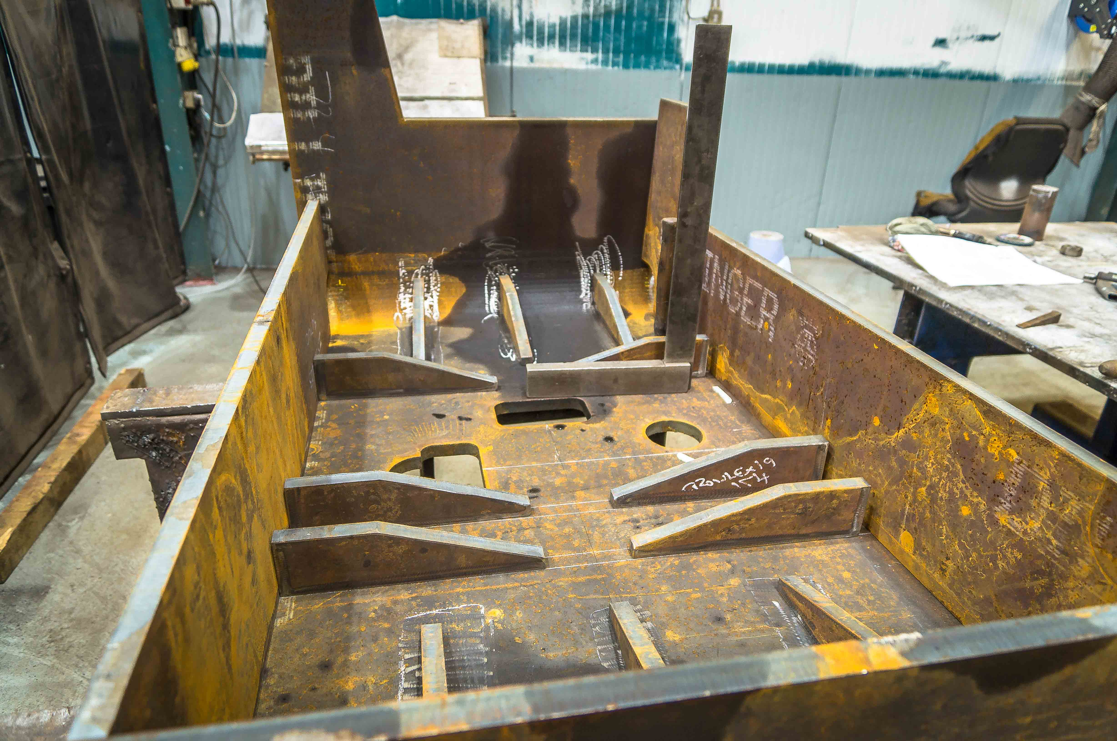

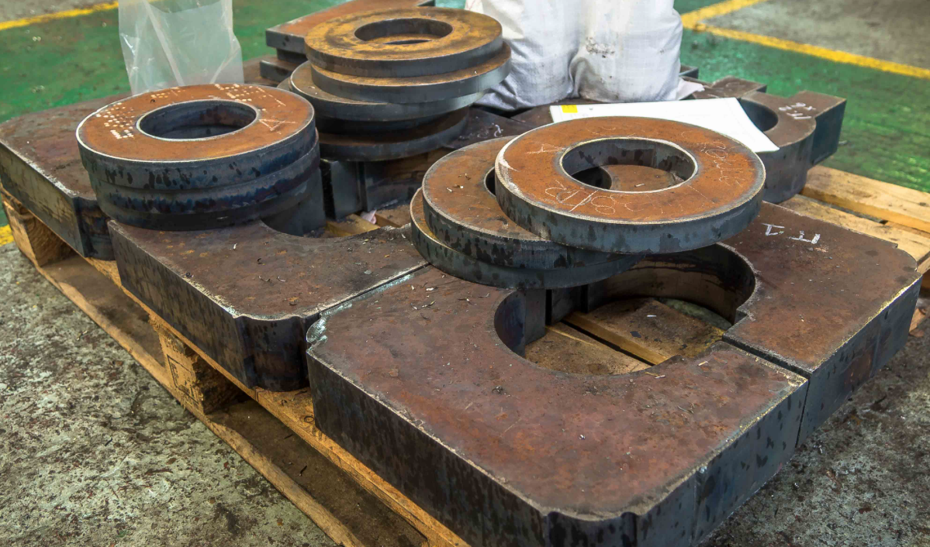

Other things
The programme for completion of the system is still by the end September 2018.
How you can help...........If you have any questions please in the first instance send them to Robert or any of the Fair Isle Electricity Company Directors who will try and get a response for you.

